**An Overview of the Tax System of**

**the Macao Special Administrative Region of**

**the People’s Republic of China**

## Ⅰ. Jurisdiction Background

Macao, a Special Administrative Region under the sovereignty of the People’s Republic of China, (hereinafter: MSAR) is situated in the southern coast of China, on the western side of the Pearl River delta. MSAR consists of a peninsula bordering the Guangdong province and two islands of Taipa and Coloane which are now connected by an area of land reclaimed from the sea (Cotai). The island area is linked to the mainland peninsula by four bridges. MSAR has an area of approximately 33.3 square kilometres, and is almost entirely urbanized. Chinese and Portuguese are the two official languages. More than 81% of the population speak Cantonese, while Portuguese is spoken by about 2.3% of the population. Putonghua and English are spoken by 45% of and 22.7 % of the population, respectively.

The People’s Republic of China resumed the exercise of sovereignty over MSAR on 20 December 1999. The fundamental principles concerning MSAR’s autonomous status, its relationship with the Central People’s Government, the political structure and the institutional framework, as well as the fundamental rights and duties of MSAR’s residents are contained in the Macao Special Administrative Region Basic Law (hereinafter: Basic Law). The Basic Law was adopted by the eighth National People’s Congress of the People’s Republic of China on 31 March 1993 and entered into force on 20 December 1999, when the People’s Republic of China resumed sovereignty over the region.

Article 2 of the Basic Law states that “*The National People' s Congress authorizes the Macao Special Administrative Region to exercise a high degree of autonomy and enjoy executive, legislative and independent judicial power, including that of final adjudication, in accordance with the provisions of this Law.*” Furthermore, Article 4 stipulates that “*The Macao Special Administrative Region shall safeguard the rights and freedoms of the residents of the Macao Special Administrative Region and of other persons in the Region in accordance with law.*”

Being a founding member of the World Trade Organisation, MSAR pursues an open economic policy and applies a zero tariff on all imports. It is an international free port allowing free movement of goods, intangible assets, and capital. It also provides an important link between the mainland China and global markets. The 2004 Mainland and MSAR Closer Economic Partnership Arrangement ensures a strict link between Mainland China and MSAR as regards trade in goods, services and investment facilitation.

MSAR is a small but vibrant open economy. It has shown a stable economic development trend in recent years, and ranks at forefront of the world in government expenditures, trade freedom, investment freedom, tax burden, monetary freedom and finance freedom. It is also an active player in the Asia-Pacific regional economy.

The economy of MSAR mainly consists of the secondary and tertiary industries and has strong links with the international economy. As a dominant part in MSAR’s industrial structure, tertiary industry develops continuously and stably. Traditional tertiary industries include tourism, finance, and real estate, among which the tourism and leisure industry is the pillar industry.

MSAR has adopted the moderately diversified development strategy in its economic policy. It has been vigorously developing four new industries: technology research and development and high-end manufacturing industries, MSAR brand industries such as traditional Chinese medicine, cultural tourism, exhibition and trade industries, and modern financial industry. These emerging new industries have been growing steadily.

## Ⅱ. Organizational Structure

According to the Organization Law of the Financial Services Bureau（Decree-Law no. 30/99/M）, the Financial Services Bureau (hereinafter: DSF) is the competent authority for tax management and administration.

DSF is subordinate to the Secretary for Economy and Finance and is led by a Director who is assisted by 2 Deputy Directors. There are 6 departments and 2 divisions, plus the Coercive Collection Bureau, the Law Department and Taxpayer Support Office, which are directly under the Director. The 6 departments and 2 divisions are, namely the Public Accounting Department, the Tax Department, the Public Asset Management Department, the Public Auditing, Tax Investigation and Appeals Department, the Information System Department, the Research and Financial Planning Department, the Administrative and Financial Division, the Notary Division. Under the 6 departments, there are altogether 11 divisions. The Coercive Collection Bureau is the tributary station.

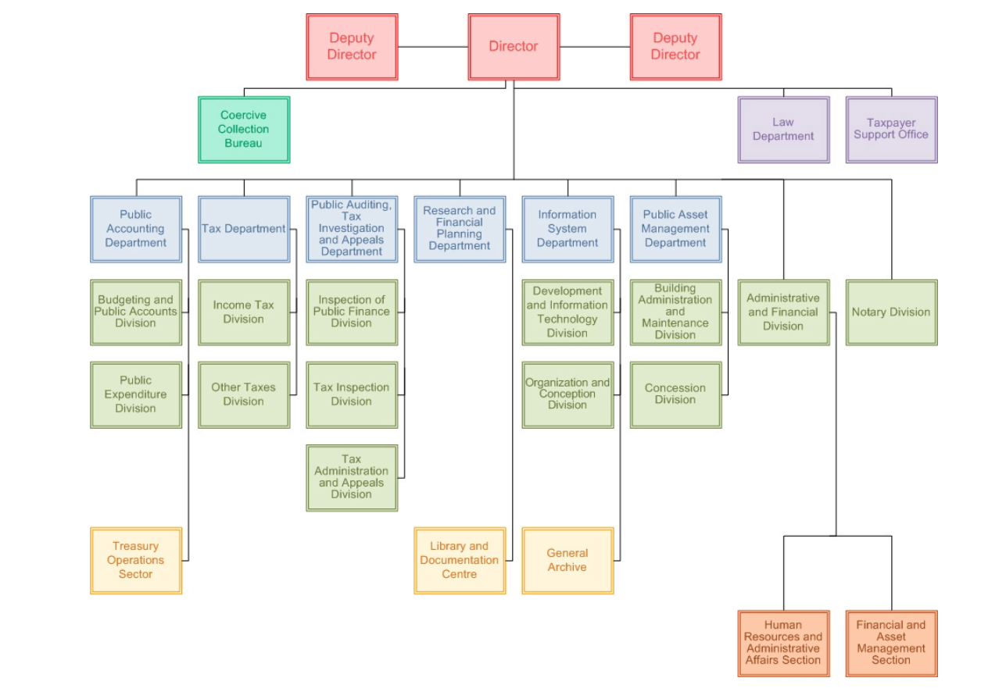

The Tax Department, the Public Auditing, Tax investigation and Appeals Department and the Coercive Collection Bureau are responsible for tax management and administration.

The Tax Department is the department responsible for local tax management and administration, including tax laws implementation, and supervision and promotion of tax compliance. There are 2 divisions under the Tax Department, namely, the Income Tax Division and the Other Taxes Division.

The Public Auditing, Tax Investigation and Appeals Department (hereinafter: DAIJ) conducts audits and inspection in public finance and taxation, and initiates legal proceedings against non-compliant tax activities. Under DAIJ, there are 3 divisions, namely, the Inspection of Public Finance Division, the Tax Inspection Division and the Tax Administration and Appeals Division.

The Coercive Collection Bureau, though an internal department of DSF, is an administrative authority in judicial litigation processes regarding tax enforcement. The Coercive Collection Bureau and its head are referred to as the tax court and tax court judge respectively as stipulated in tax laws.

## Ⅲ. Current Tax System

Pursuant to the Basic Law, MSAR practises an independent taxation system (Art. 106) and it is empowered to enact laws concerning all matters of taxation. MSAR levies 10 types of taxes, and the taxable year is from 1 January to 31 December.

The current tax system in MSAR is based on direct taxes with indirect taxes as a supplement. It has the feature of having a few types of taxes and simple tax structure. The main types of taxes currently in place are Business Tax, Salaries Tax, Property Tax, Profits Tax, Consumption Tax, Motor Vehicles Tax, Stamp Duty, Tourism Tax, Special Gaming Tax and Vehicle License Plate Usage Tax.

[Click here for more detailed information.](https://www.dsf.gov.mo/tax/tax_law.aspx?lang=en&FormType=1)

**Ⅳ. Overview of Preferential Tax Measures**

MSAR promulgates tax relief measures in the annual government budget. In the Budget of the Fiscal Year 2024, it states the following tax relief measures:

1. Business Tax: Exemption of Business Tax for the taxable year 2024.
2. Property Tax

For the taxable year 2023,

◆ Deduction of MOP 3,500 on Property Tax if the taxpayer(s) concerned is(are) MSAR resident(s). That is, this tax relieve is not applicable for the property owned by a legal person, a natural person commercial enterprise owner or a non-resident of the MSAR. Furthermore, if the property is owned by more than one natural person, this deduction is applicable provided that at least one of the owners is a MSAR resident.

◆ The urban property tax rate for leased premises reduces to 8%.

1. Profits Tax

For the taxable year 2023,

◆ Tax allowance is MOP600,000.

◆ Income obtained or generated in Portuguese-speaking countries shall be exempted from the Profits Tax, on the condition that the corresponding taxable income has been taxed in those countries.

◆ Interest obtained through debt securities, which are issued in MSAR, as well as income obtained from the purchase and sale, redemption or other availability, shall be exempted from the Profits Tax.

◆ To encourage research and development on technological innovation, additional deduction of the taxable income shall be allowed for companies which are Group A taxpayer. For the first MOP3 million of the expenditure, the deduction amount is 300% of same, while for the remaining amount, it will be 200%. The total deduction amount must not exceed MOP15 million.

1. Salaries Tax

◆ For the taxable year 2024, tax allowance is MOP 144,000, and 30% of the amount of tax to be paid is exempted.

◆ 60% of the tax amount paid for the taxable year 2022 is refunded to taxpayers who hold MSAR Resident Identity Cards on 31 December 2022. The tax amount to be refunded is capped at MOP 14,000.

Stamp Duty

For the taxable year 2024,

◆ Exemption of stamp duty on insurance contracts and banking service charges.

◆ Exemption of stamp duty on auctions of property, rights of ownership in movable or immovable property.

◆ Exemption of stamp duty on all admissions or tickets of performance, exhibition or entertainment event.

◆ Exemption of stamp duty on the issuance and acquisition of debt securities.

◆ Exemption of stamp duty on putting up or placement of advertisements, signboards and publicity materials that are already exempted from the license fee by the Municipal Affairs Bureau.

Tourism Tax

For the taxable year 2024, exemption of the Tourism Tax on the goods and services rendered by restaurants and luxurious restaurants of classes 1 and 2 (Group 1), as stipulated in Law no. 8/2021 and Decree Law no. 16/96/M, respectively.

## Ⅴ. Tax Collection and Administration

According to its Organization Law, besides being responsible for public finance, DSF is the competent authority for tax management and administration. It monitors the implementation and enforcement of tax laws to ensure tax compliance.

DSF is endeavor to keep up with the reform of tax regime by revising existing tax laws and enacting new ones, and by extending channels and simplifying procedures in tax collection, in order to be align with the international and regional economic and social environment. Measures introduced include the digitization of Property Tax and Business Tax, the automatic issuance of collection documents, and tax payment over the counter at designated banks. These new measures enable more timely responses to taxpayers' requests, enhance communication between the tax authority and the taxpayers, and effectively reduce administrative costs.

In recent years, MSAR has proactively developed three e-government service platforms: “One Account”, “Business and Associations Platform” and “Government Affairs Platform”. In optimizing government processes through digitalization, these platforms enable broader and more convenient services to be rendered to various groups of people. In the area of tax administration and management, DSF and the Public Administration and Civil Service Bureau have launched the “Macao Tax” and “One Account” mobile applications respectively. “Macao Tax” primarily provides tax-related information, while "One Account" offers general tax inquiry and payment services, allowing taxpayers to manage various tax-related matters any time.

## Ⅵ. Taxpayer Services

Tax payment may be made through traditional channel, i.e. in person at DSF collection offices located in the "Finanças" Building, the Coercive Collection Bureau , the MSAR Government Services Centre and the Macao Government Services Centre in Islands. Taxpayers may also pay taxes over the counter at designated banks or through e-banking of these banks. With the development of e-government, taxpayers may now pay taxes electronically through various government mobile applications, namely “Macao Tax”, “One Account” or “Business and Associations Platform”.

For the convenience of taxpayers, automatic self-service kiosks have been set up at various locations. Only with their identity cards, taxpayers are able to check their tax-related information at these kiosks. These automatic self-service kiosks are located at the "Finanças" Building, the MSAR Government Services Centre, the Coercive Collection Bureau and the Macao Government Services Centre in Islands, and operate 24 hours daily.

DSF also disseminate tax-related information on-line through its tax obligations column on WeChat Official Account and its official website to keep taxpayers informed of the updates, the due dates of various taxes and the documentation requirements, etc.

There is also the Taxpayer Support Office which accepts complaints and representations from taxpayers regarding the process of their tax filings and helps to locate the filings and analyze the filings as quickly as possible.

**Ⅶ. Tax Legislation Process**

The Macao Special Administrative Region Basic Law was adopted by the eighth National People’s Congress of the People’s Republic of China on 31 March 1993 and entered into force on 20 December 1999, when the People’s Republic of China resumed sovereignty over the region.

In accordance with Article 31 of the [Constitution of the People's Republic of China](https://en.wikipedia.org/wiki/Constitution_of_the_People%27s_Republic_of_China), MSAR has special administrative region status, which provides constitutional guarantees for implementing the policy of "[one country, two systems](https://en.wikipedia.org/wiki/One_country,_two_systems)" and the constitutional basis for enacting the Basic Law of the Macau Special Administrative Region.

Article 18 of the Basic Law stipulates that “*The laws in force in the Macao Special Administrative Region shall be this Law, the laws previously in force in Macao as provided for in Article 8 of this Law, and the laws enacted by the legislature of the Region.*”, and also “*National laws shall not be applied in the Macao Special Administrative Region except for those listed in Annex III to this Law. The laws listed therein shall be applied locally by way of promulgation or legislation by the Region.*” Meanwhile, Article 17 states that “*The Macao Special Administrative Region shall be vested with legislative power.*”

Pursuant to the Basic Law, MSAR practises an independent taxation system (Art.106) and is empowered to enact laws concerning all matters of taxation.

Ever since its return to China, MSAR has been actively revising existing tax laws and regulations, and introducing new ones. In 2003, MSAR made substantial revision to the Profits Tax and the Salary Tax Regulations. It has also introduced a series of new tax laws, such as Motor Vehicles Tax Regulation (Law No. 5/2002).

Currently, all 10 types of taxes are governed respectively by their own individual regulations. There is no one single uniform tax concept and principle introduced to cover comprehensively each and every individual tax law. Therefore, MSAR is drafting the Tax Code, which will integrate the provisions of prevailing individual tax laws. The Tax Code will clearly define the rights and obligations in tax legal relationships, and establish principles in tax procedures, litigation, and enforcement. On 15 October 2021, the Executive Council completed the discussion on the draft of Approval of the Tax Code and referred it to the Legislative Assembly for deliberation. The legislative procedure for the introduction of the Tax Code is expected to be completed shortly to further streamline the existing tax system.

## Ⅷ. Future Tax Reform Plan

In order to optimize the business environment of the MSAR and enhance its competitiveness in attracting investment, the MSAR government is making major reforms to the current tax laws and formulated a set of tax regulations that is unified and covers the entire tax legal relationship. These regulations form a modern tax system that is consistent with international tax standards in order to cope with the long-term development of the MSAR economy. The draft of the Approval of the Tax Code consists mainly of two parts, namely the Approval of the Tax Code and the Tax Code. The Approval of the Tax Code is comprised of 29 articles, which aims at streamlining all existing individual tax laws, such as revising and abolishing certain provisions of existing tax regulations, and unifying Chinese and Portuguese terminologies. There are six sections in the Tax Code, which, in turn, are sub-divided into 312 articles. The six sections are, in order, General Part, Tax Legal Order, Tax Legal Relationship, Tax Proceedings, Tax Legal Proceedings and Tax Foreclosure Proceedings. It will consolidate the provisions of existing tax laws. Each section will focus on their respective area of the existing tax laws. Hence, a more competitive and attractive modern tax system will be able to be established, thus making it to be more compatible with the international tax environment.

## It is worth noting that the Tax Code will introduce the concept of transfer pricing for the first time. It will set out the regulation on transfer pricing, and the conditions and requirements for advance pricing arrangement (APA). The request for APA is subject to the approval of the director of DSF. To supplement the Tax Code, the Administrative Regulation on Transfer Pricing Implementation Guidelines will soon be introduced. The implementation of these will further enhance the cooperation among tax authorities, particularly in the current globalization trend and the prevail of multinational enterprises.

## Ⅸ. International tax cooperation

**(1) International Tax Treaties/Arrangements**

MSAR has been actively extending its international network of tax agreement. By far, MSAR has concluded tax treaties/arrangements with 8 countries/regions. Specifically, MSAR has signed tax treaties/ arrangements with the mainland China, Hong Kong, Portugal, Belgium, Vietnam, Cape Verde, Mozambique, and Cambodia for avoidance of double taxation and prevention of tax evasion; an agreement with Taiwan of China for avoidance of double taxation for aviation enterprises; and an agreement with Portugal on mutual tax privileges applicable to representative offices and staffs.

**(2) Tax Information Exchange Agreement**

Until now, MSAR has concluded tax information exchange agreements with 14 countries/regions, including Ireland, Argentina, the United Kingdom, Guernsey, Sweden, Japan, Greenland, India, Australia, Denmark, the Faroe Islands, Iceland, Norway and Finland. After the territorial extension of The Multilateral Convention on Mutual Administrative Assistance in Tax Matters signed by China, MSAR is able to exchange tax information with more than 140 countries/regions. To maintain its commitment, MSAR will continue initiating negotiations with new treaty partners and fully engage in exchange of information mechanisms at international standard.

**(3) The Belt and Road Initiative Tax Administration Cooperation Mechanism**

MSAR is a Council Member of the Belt and Road Initiative Tax Administration Cooperation Mechanism (hereinafter: BRITACOM). Through BRITCOM, MSAR is able to enhance tax administration cooperation with the other jurisdictions that subscribe to the Belt and Road Initiative. The Belt and Road Initiative Tax Administration Capacity Enhancement Group (BRITACEG) under BRITACOM has set up the Belt and Road Initiative Tax Academy·Macao (BRITA·Macao), with focus on Portuguese-speaking jurisdictions. The Academy provides tax intellectual products, professional training and technical supports for tax authorities of the Portuguese-speaking jurisdictions, which aims at enhancing their capacity of tax administration and management.

## Ⅹ. Others

## None.